General Chemistry Lab/Inorganic Chemistry Lab Report Sample #1
(YTU-Inorganic Chem Devision)
Name: John Smith  Name of Partners: Jane Jones, Martin Sander  Class Name/ Group: General Chemistry Lab. 1/ Group 1  Date Lab Report: 26 November 2009  Experiment Number: 1 Exp. Group Number: 2 | YILDIZ TECHNICAL UNIVERSITY  Department of Chemistry  Inorganic Chemistry Division

Experiment Name: Boiling Point of Water

Introduction:
Kinetic theory states that all molecules in matter are in constant motion (Kane and Sternheim, 1984). As these molecules absorb more energy they have a higher amount of random movement. As energy is absorbed in the form of heat the average kinetic energy (temperature) of the molecules will increase except during a phase change. The absorbed energy used in the phase change breaks the attractive forces between the molecules, thus transformation occurs in the orientation of the molecules. An example of a phase change would be the boiling point of water which is a change from a liquid to a gas. This can be observed by using a temperature versus time line graph when the slope becomes zero (plateau) The boiling point of water is expected to be 100.00 oC (Merck, 1976).

Objective:
The purpose of this experiment is to determine the boiling point of water.

Hypothesis:
If the pressure in the classroom is close to 1 atmosphere, then the boiling point of water should be approximately 100 degrees Celsius.

Materials List:
500 ml beaker distilled water, thermometer, hot plate,
Word Processing Software

Procedure:
The required materials were selected and taken to the workstation. The beaker was filled with approximately 300 ml of distilled water. The beaker was gently placed on the hotplate.
The thermometer was placed in the beaker and the initial temperature was recorded. The hotplate was switched on to high.
The temperature was recorded every 2 minutes until 6 minutes after boiling began.
The hotplate was turned off and the materials were allowed to cool for at least 10 minutes before the equipment was dismantled.

Figure 1. The equipment for this experiment was set up as shown in this figure.
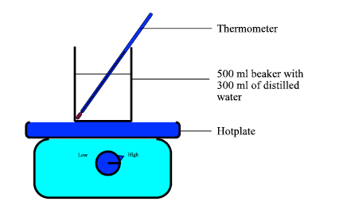

Data / Results / Observations:
Quantitative Results

Table 1 Graph displaying data obtained from the heating of water from 0 to 16 minutes

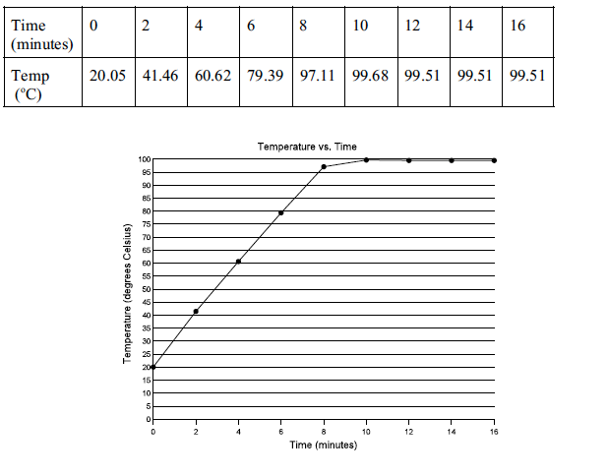
Figure 2. A line graph of temperature versus time of the data obtained in Table 1
Qualitative Results
Numerous small bubbles formed at the bottom of the beaker at 70.6 ºC. The size and rate of bubble formation increased as the temperature increased. At 100.0 ºC the rate and size of bubble formation remained constant. At that temperature, there was constant production of steam.

Calcuations / Analysis:

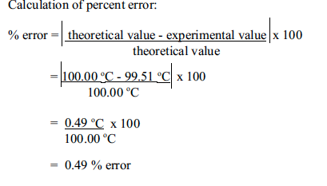

Conclusion:
It was determined from the data plotted in the temperature versus time graph (Figure 2) that the boiling point of water is 99.51 oC. This concurs very closely with the stated hypothesis; therefore the experiment was deemed a success. The percent error was found to be 0.49%. Possible sources of error could have involved impurities in the water and human error in reading the thermometer. Possible sources of error may be impurities in the water which may be chemicals from dirty glassware. Improvements would include more accurate thermometers, clean equipment and proper reading of the thermometer.

References:
Kane, Joseph W. and Morton M. Sternheim. Physics. New York: John Wiley & Sons, 1984 ed.
Merck, Josef. Merck Index of Chemical Constants. New
York: Benjamin/Cummings Publishing Company Inc. 1976.

